Requirement Analysis

Functional Requirements
- FR1
Movie Listing: The system shall display all movies currently playing, including movie title, language and duration.
- FR2
Show Listing: The system shall allow the customer to select a movie and display its available shows with screen number and start time
- FR3
Seat Layout: The system shall display the seats for a selected show and mark every seat as AVAILABLE or BOOKED.
- FR4
Booking: A customer selects one or more seat numbers for a show. If any selected seat is already BOOKED, the whole booking is rejected and no seat changes state. Booking is confirmed only after payment succeeds.
- FR5
Price Calculation: The system shall calculate the total amount using SILVER = ₹150, GOLD = ₹250 and PLATINUM = ₹400 for every selected seat
- FR6
Payment: Exactly one payment method shall be selected per booking: UPI, Card or Cash. If payment fails, seats are released and the booking status becomes FAILED.
- FR7
Ticket Printing: After successful payment, the system shall print a ticket containing booking ID, movie, screen, show time, seat numbers, total amount and status
- FR8
Cancellation: The system shall allow cancellation of a confirmed booking and make all seats belonging to that booking AVAILABLE again.
- FR9
Movie Search: The system shall allow the customer to search currently playing movies by title or language and display matching movies.
- FR10
Available Seat Count: The system shall display the number of AVAILABLE seats for each show.
- FR11
Customer Registration: The system shall collect a non empty customer name and accept a phone number only when it contains exactly 10 digits.
- FR12
My Tickets: The system shall display all CONFIRMED tickets belonging to the current customer.
- FR13
Booking Summary: Before payment, the system shall display the selected movie, screen, time, seat numbers and calculated total amount
- FR14
Unique Booking ID: The system shall automatically generate a unique booking ID for each booking using a shared static counter
- FR15
Payment Transaction ID: After successful payment, the system shall store the payment transaction ID and print it on the ticket.
- FR16
Booking Status Lookup: The system shall allow the customer to enter a booking ID and view its current status.

Non-Functional Requirements
- NFR1
Modularity: Each major responsibility is implemented in a separate Java class/file.
- NFR2
Extensibility: A new payment method can be added as a Payment subclass without changing the core booking flow.
- NFR3
Input Validation: Invalid menu, movie, show and seat choices produce clear messages without crashing the program
- NFR4
Maintainability: Methods have focused responsibilities, meaningful names are used, magic numbers are replaced by constants, and repeated code is minimized

Noun Verb Analysis

Noun | Class? | Reason | Related verbs
Movie | Yes | Own data and identity. | list, select
Seat | Yes | Represents one physical seat and its type. | display, book
Screen | Yes | Represents one auditorium and owns seats. | contain, find
Cinema | Yes | Represents the theatre and owns screens. | add, list
Show | Yes | Represents one movie screening at a screen and time. | select, display
ShowSeat | Yes | Stores seat status for one particular show. | book, cancel, check
Customer | Yes | Represents the person making a booking. | enter
Booking | Yes | Represents booking identity, seats, amount and status. | confirm, cancel, fail
Payment | Yes | Defines the payment contract. | pay
UPI/Card/Cash | Yes | Concrete payment behaviours. | pay
Price | No | A value calculated by PriceCalculator, not an independent entity. | calculate
Seat layout | No | A view of Show's ShowSeats; it is not an independent object. | display
Ticket | No separate class | The required ticket is formatted and printed by TicketPrinter. | print
Menu | No | Console UI logic handled by main. | choose, read

Main Verbs Identified
listMovies(), listShows(), displaySeats(), bookSeat(), calculateTotal(), pay(), printTicket(), cancelBooking(), confirm(), fail(), cancel().

Classes and Responsibilities

Class | Data | Methods | Knows / Does / Must NOT
Movie | title, language, durationMinutes | getTitle(), getLanguage(), getDurationMinutes() | Knows movie information; returns it. Must not manage shows, seats or payments.
Seat | number, type | getNumber(), getType() | Knows physical seat identity/type. Must not know booking status for a show.
Screen | screenNumber, seats | findSeat(), getSeats() | Owns physical seats for one auditorium. Must not calculate ticket prices.
Cinema | name, screens | addScreen(), getScreen() | Owns screens. Must not process payments.
Show | movie, screen, startTime, showSeats | findShowSeat(), displaySeats() | Represents one screening and its show-specific seat states. Must not process payment.
ShowSeat | seat, status | bookSeat(), cancelSeat(), isAvailable() | Controls seat status for one show. Must not calculate total booking price.
Customer | name, phone | getName(), getPhone() | Stores customer identity/contact information. Must not perform booking orchestration.
Booking | bookingId, customer, show, seats, totalAmount, status | confirm(), cancel(), fail(), addSeat() | Stores booking state. Must not print tickets or perform payment logic.
Payment | transactionId | abstract pay(amount) | Defines payment contract. Must not know booking workflow.
UpiPayment / CardPayment / CashPayment | payment-specific behaviour | pay(amount) | Perform a concrete payment method. Must not manage seats or bookings.
PriceCalculator | price constants | calculateTotal(list), calculateTotal(seat) | Calculates prices only. Must not change seat status.
TicketPrinter | none | printTicket(Booking) | Formats/prints tickets only. Must not book or cancel seats.
BookingService | priceCalculator, ticketPrinter, bookings | book(), cancelBooking(), findBooking(), printMyTickets() | Orchestrates the booking flow. Must not contain payment-method-specific logic.
main | Scanner and console state | menu/input/helper methods | Handles menu and input. Must not contain entity business rules.

Relationships and Justification

Pair | Relationship | Lifetime justification
Cinema — Screen | Composition | Cinema creates/owns its Screen objects. If the cinema is destroyed, its screens are part of that cinema and are destroyed with it.
Screen — Seat | Composition | Screen creates/owns its Seat objects. If the screen is destroyed, its physical seats belonging to that screen no longer exist in the model.
Show — Movie | Aggregation | A Show references an existing Movie. Destroying a Show does not destroy the Movie, which can appear in another Show.
Show — Screen | Aggregation | A Show references an existing Screen for a particular time. Destroying the Show does not destroy the Screen.
Show — ShowSeat | Composition | Show creates ShowSeat objects representing seat status for that screening. They have no independent meaning after the Show is removed.
Booking — Customer | Association | Booking refers to a Customer, but neither object's lifetime depends on the other.
Booking — ShowSeat | Aggregation | Booking stores references to existing ShowSeat objects. Cancelling/deleting a booking must not destroy the seat objects.
Booking — Payment | Composition | The payment object is created for the booking transaction and belongs to that transaction's lifecycle.
Payment — UpiPayment/CardPayment/CashPayment | Inheritance | The concrete payment classes are specialized forms of the abstract Payment contract.
BookingService — Booking | Association | BookingService manages bookings but does not own their lifetime; a Booking can remain after a service call finishes.

Class Diagram
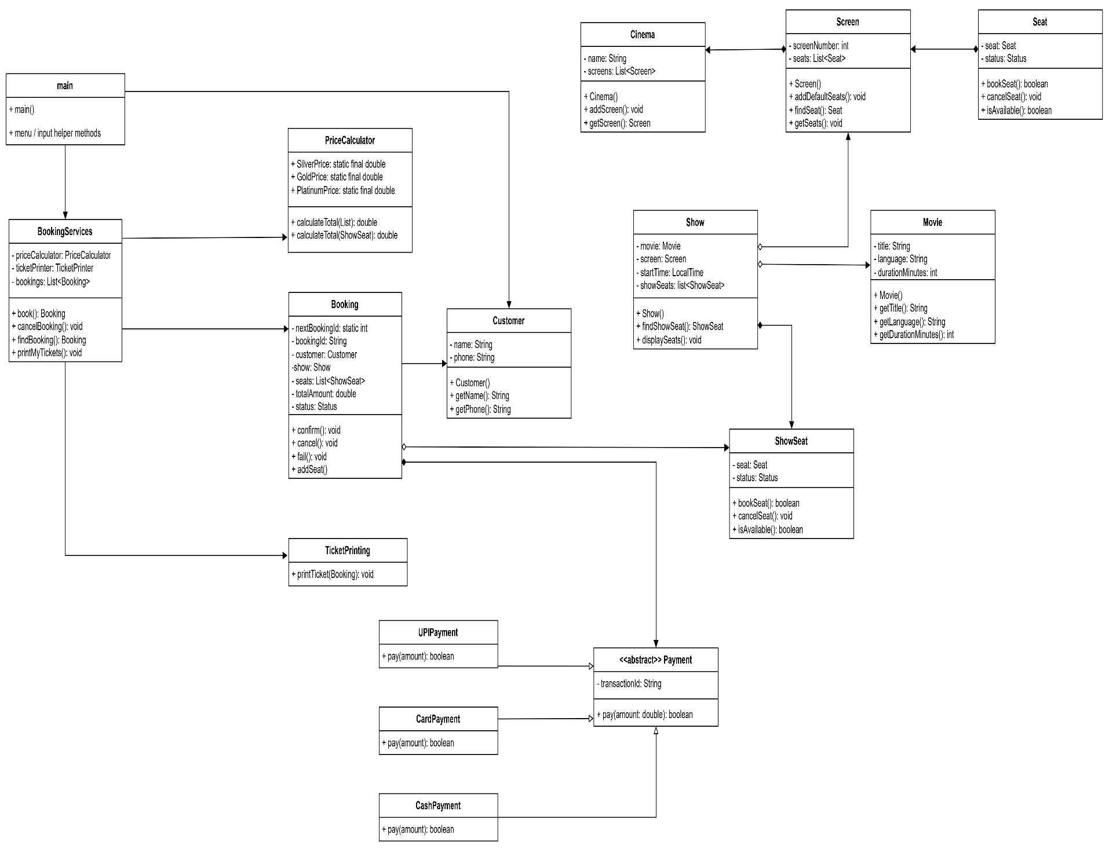

Sequence Diagram
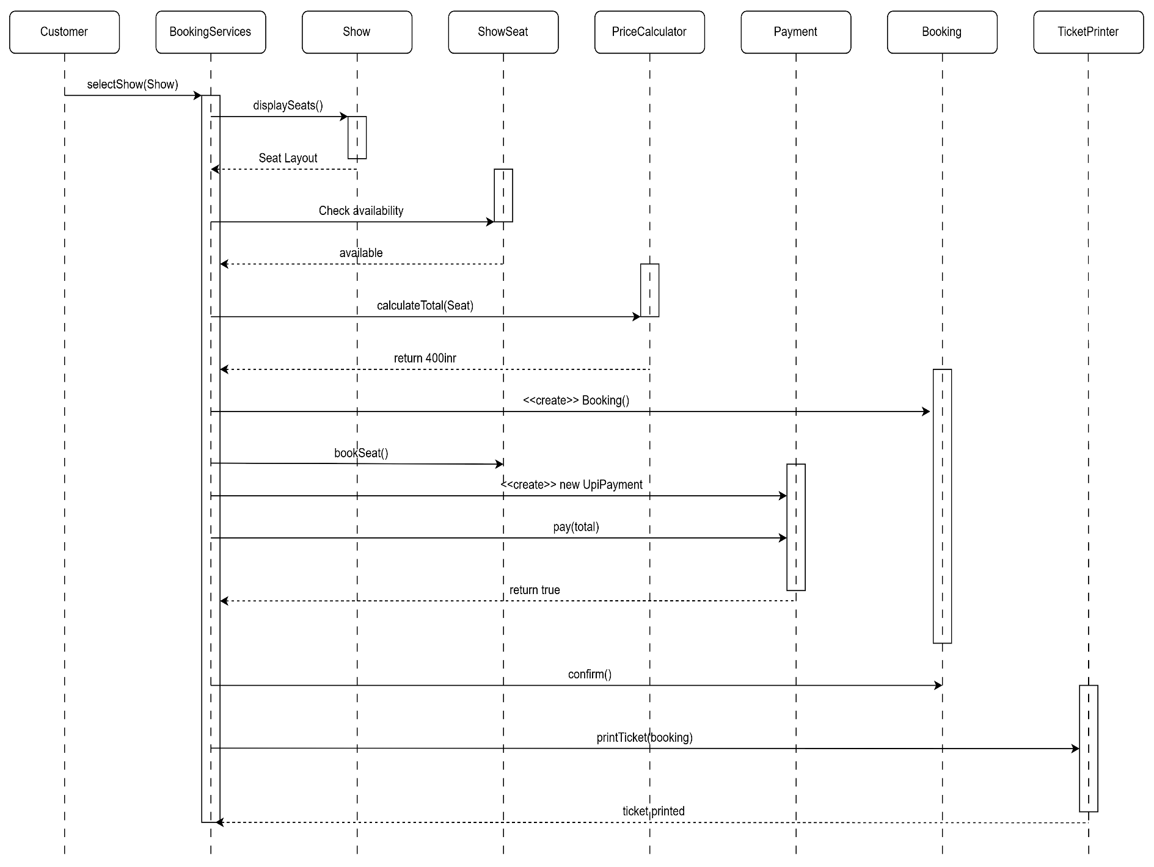

SOLID Principles

- S - Single Responsibility: PriceCalculator calculates prices, TicketPrinter prints tickets, Payment subclasses perform payment, and BookingService orchestrates the flow. Booking does not print tickets.
- O – Open/Closed: Payment is an abstract contract. A future NetBankingPayment can extend Payment without changing the core BookingService payment call
- L – Liskov Substitution: Any UpiPayment, CardPayment or CashPayment can be used through a Payment reference and provide the required pay(amount) behaviour.
- I – Interface Segregation: No large interface was introduced because the required design already uses the small abstract Payment contract.
- D – Dependency Inversion: BookingService receives PriceCalculator and TicketPrinter objects through its constructor instead of creating those dependencies internally. Payment is also passed into the booking operation.

Output

